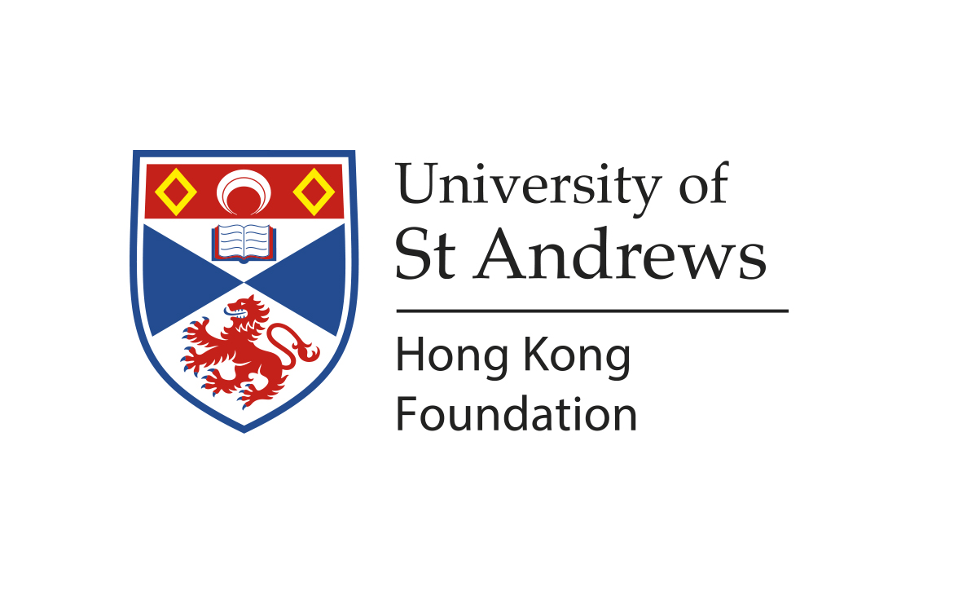
The University of St Andrews Hong Kong Foundation Limited
Gift Remittance

Hong Kong taxpayers can make donations in Hong Kong dollars, US dollars, British pounds or Chinese renminbi via The University of St Andrews Hong Kong Foundation Limited. Contributions will be tax deductible as provided for under Section 88 of the Hong Kong Inland Revenue Ordinance.

Cheques
If you would like to remit a cheque in Hong Kong dollars, US dollars, British pounds or Chinese renminbi, please make your cheque payable to The University of St Andrews Hong Kong Foundation, and mail it to:

The University of St Andrews Hong Kong Foundation
Room 304, 3rd Floor, Tesbury Centre
28 Queen's Road East
Wan Chai, Hong Kong

Hong Kong Contact: Miss Bibi Choi/ Miss Sheyla Lau - Tel: 2866 1535 Email: hk@globalphilanthropic.com
University of St Andrews Contact: Mrs Susan Donald Tel: +44 (0)1334 46 1906 Email: sk27@st-andrews.ac.uk

WIRE TRANSFER
If you would like to remit via wire transfer to The University of St Andrews Hong Kong Foundation, please use the following information:

Bank Name: HSBC Hong Kong
Bank Address: 1 Queen’s Road Central, Hong Kong
Swift Code: HSBCHKHHHKH
Beneficiary: THE UNIVERSITY OF ST ANDREWS HONG KONG FOUNDATION LIMITED
Account No.: 582-319778-838

Please provide the following information to The University of St Andrews Hong Kong Foundation in Hong Kong, when you submit payment via cheque or wire transfer. Email to hk@globalphilanthropic.com [Global Philanthropic acts as agent for The University of St Andrews Hong Kong Foundation in Hong Kong.]

Donor name:

Donor address:

Donor phone number:

Donor email:

We will publicly recognise your support in donor lists and publications. Please check the box below if you do not wish to be included in these publications. □ I do not wish to be publicly recognised
Purpose of the gift: □ Hong Kong Scholarship □Unrestricted
□ Other – please specify

Gift amount: Gift currency :
Form of Payment: □Cheque (cheque no.) (date of cheque)

□Wire (confirmation no.) (date of wire)

